**How to use Linux in Windows using “Windows Subsystem for Linux”** (**WSL**)

**How to Compile and Run a C/C++ Code in Linux**

I am using Linux Ubuntu. To compile and run a C or C++ program on any Linux we need to install:

1. GNU C and C++ compiler / GCC collection
2. Development tools
3. Development libraries
4. IDE or text editor to write programs

**Installation of GCC**

**$ sudo apt-get update**

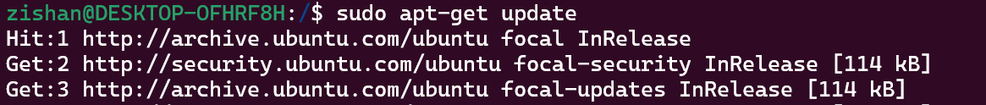

**$ sudo apt-get install build-essential manpages-dev**

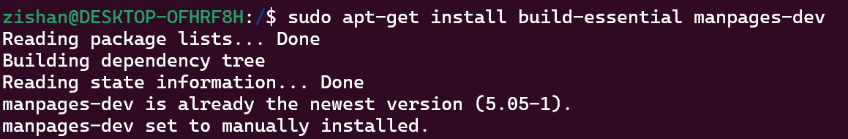

**$ sudo apt install gcc**

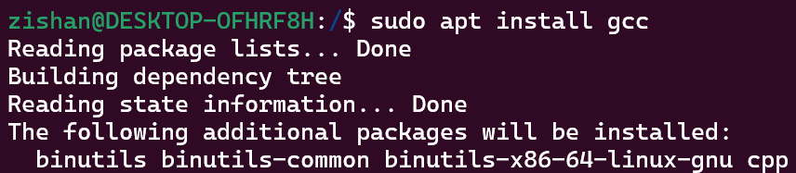

**Verify installation**

Type the following command to display the version number and location of the compiler on Linux:

$ whereis gcc  
$ which gcc  
$ gcc --version

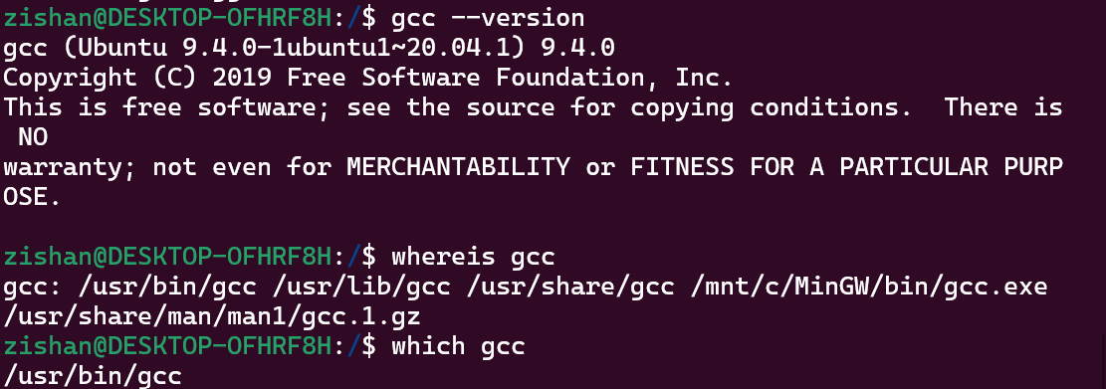

**Compiling and running a simple C++ program**

**My CPP program name is mylearning.cpp**

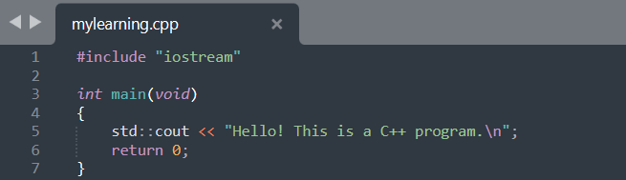

To compile this program, enter:

**g++** mylearning.C -o mylearning2

*## or use the following syntax ##*

**make** mylearning

To run this program, type:

.**/**mylearning

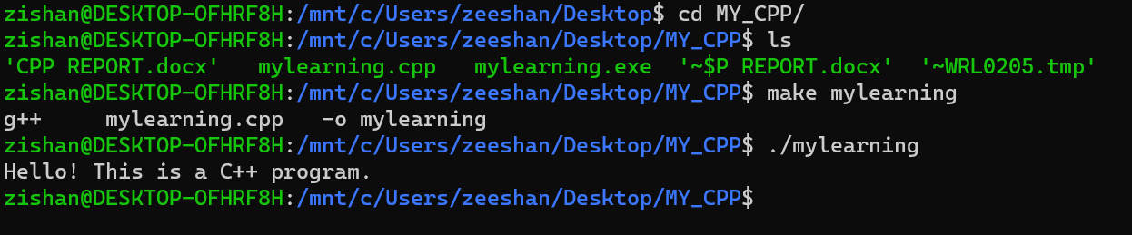

Linux:

How to change password:

$ passwd